Ok, so you are here in RCOS and you chose to do pellio, neat.
This is my attempt at providing some useful documentation so you aren't just gonna guess on what this all means (for backend people)
Let's go through this janky file system step by step.
So, you got a folder called PellioRPI, hop right into that and you will see this
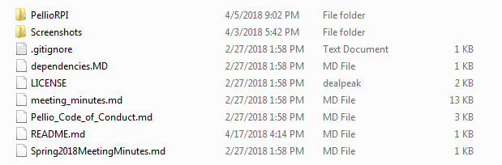
Hop into PellioRPI (again) and you'll see:
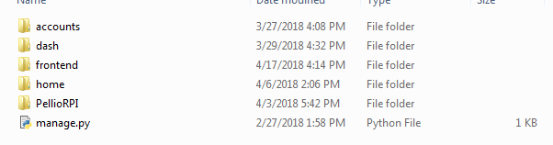
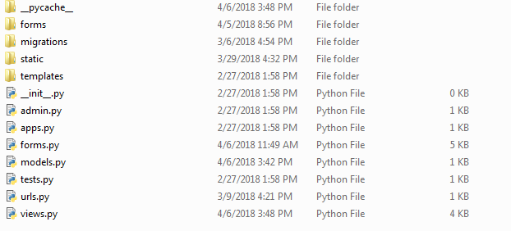
(this is where you want to run the command python manage.py runserver)
PellioRPI, manage.py, and frontend are all out of my expertise so let's look at home first.
There are about.. 3 files that matter here: Urls.py, forms.py, and models.py
Ok, hop into Urls.py real quick and see a whole lot of.. stuff.
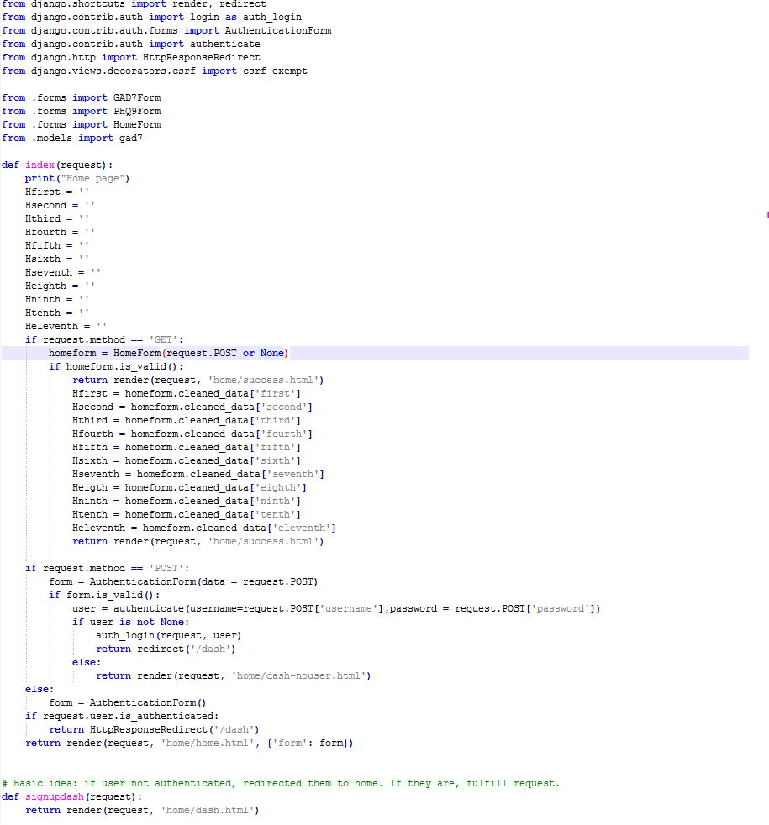
This is ugly af.
So, you see from .forms import *form?
Yeah, so that import forms from the forms.py

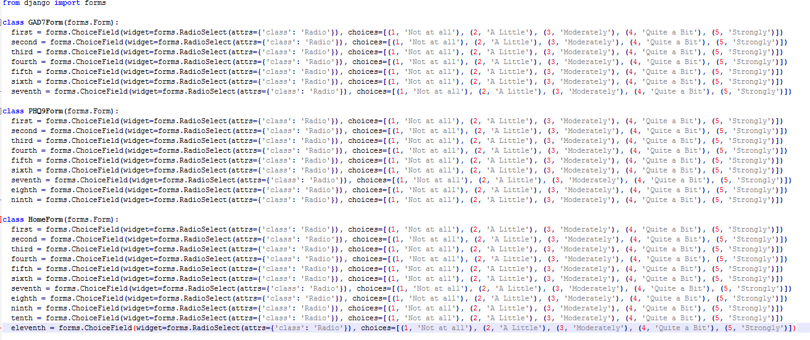
You gotta import them, so views.py knows which forms to use, same goes with models.
[Pic of models here]
So what's models and forms tho? A form is a way to encapsulate data, and a model is a way to send it to the database.
Anyways, back to the code.
If the request method is GET, that means it's getting some data, so homeform is equal to HomeForm (from forms) and if the form is valid (ie.. enough data is in it, if the data fits) then you can save the data into the database (which we haven't done yet lol).
If the method is post, it is just saying that the user is just getting there to the page. Here is where we redirect you. If you're form is authenticated and valid that means you are currently logged in as a user, you get redirected to the dashboard. If not you get to stay on the main page.
The signupdash(request) just redirects you to the signup html page.

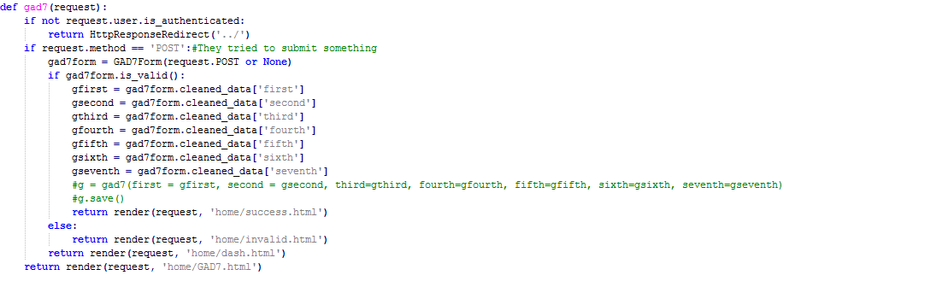
Woah, more stuff. So this chunk of codes first asks you if you are logged in, if you aren't you go back to where you were. If you are authenticated, you can try to submit the form (survey, look at gad7.html), if it isn't valid (not all areas answered) then you get yelled at and go to invalid. If it is valid, you get the data from the gad7form (by cleaning it) and then submit that to the database.
Ok enough of this, let's go back (in the file explorer) and go into accounts

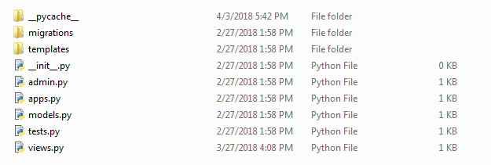
Telling you right now, the only thing that honestly matters here is views.py (the other *.py are all template'd and empty).
So let's look at Views.py (I'm not front end so I don't know much about that stuff but if you are, templates is where the signup.html is stored).
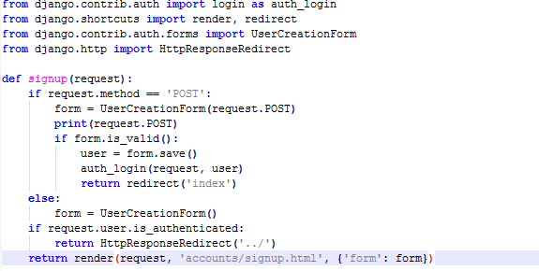
This simple view is here to catch you when you get linked to /signup/, you will will make a form (a way for the database to hold data) with your credentials via the django function UserCreationForm. Wait.. when would form not be valid? It wouldn't be valid if passwords didnt match, password was too simple, etc. If it's all cool and good then it gets saved. Then you are logged in and redirected to Dash.
OH WAIT THE URLS.PY
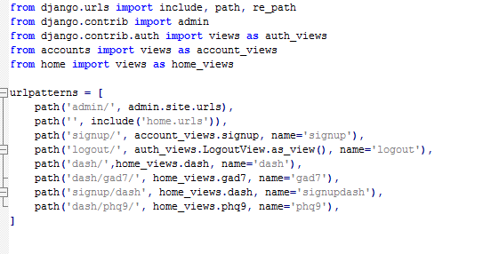
This is in the PellioRPI/PellioRPI/PellioRPI and holds literally all the URLs in the project.
Basically, the first argument is the url itself, the second is where django can find that url specifications, and the third is the function name (in views, ie def gady(request)) in the views.py

